LAB 04  
  
1) **Comparison queries**

Find laptops with the price equal to $999.99  
  
Find laptops with prices not equal to $1299.99

Find laptops with a price greater than $1500.  
  
Find laptops with a price greater than or equal to $1399.99.

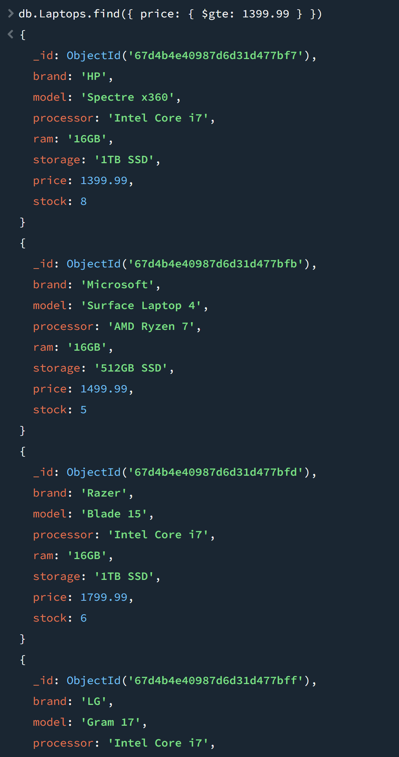

**2) Logical queries**

Find laptops with a price less than $1000 OR with a stock greater than 10.

laptops with a price less than $1000 AND with a stock greater than 10.

Find laptops with a price NOT equal to $999.99

**3)Element operators**

o Find laptops with the "description" field using exists.

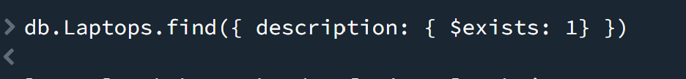  
o Find laptops with the "reviews" field missing.

4) **Array operators**

o Find laptops with a genre of "Gaming" in their genres array.

o Find laptops with the genre "Business" using $in.



**5)Text Search Operators:**

o Perform a text search for laptops with the word "performance".

6) Array Update Operators  
o Add a new review to a laptop with a specific title.  
